
COMPUTER APPLICATION TECHNOLOGY

2024
planning, summary, analysis and interpreatation
Name : Mbasa Batyi
GRADE : 12 M
District : CHRIS HANI DISTRICT
teacher : MR Muza
task : PHASE 1
Sector : waste management
focus job : WASTE reduction sepecialist

QUEEN’S COLLEGE BOYS’ HIGH SCHOOL |mbatyi@queenscollege.co.za

Table of Contents
Table of Figures 0
EXCEL ANALYSIS AND INTERPRETATION 1
ACCESS ANAYLSIS AND INTERPRETATION 4

Table of Figures
Figure 1: Are you aware of a Waste Reduction Specialist. 1
Figure 2 : Universities with a recycling system implemented. 1
Figure 3 : Percentages of the duties of a Waste Reduction Specialist. 2
Figure 4 : Do Waste Reduction Specialists implements systems to reduce waste. 2
Figure 5 : Scale of the level of assistance a Reduction Specialist Requires. 3
Figure 6 : Estimation of the annual gross salary of a Waste Reduction Specialist. 3
Figure 7 : Query for recycling centres 4
Figure 8 : Query for the average estimated annual salary 4
Figure 9 : Query for the amounts above the correct annual pay check and estimated hour salary 4
Figure 10 : Query for people who choose UCT with a rate of below 5 5
Figure 11 : Report for the analysis of the information derived from the respondents. 5

EXCEL ANALYSIS AND INTERPRETATION

Figure 1: Are you aware of a Waste Reduction Specialist.
Figure 1 is a Horizontal Bar graph derived from the information collected from the survey that was issued out to the public, this bar graph shows how many people responded and from that total number being 63. It was split into responses of “Yes” and “No” to the question on the title of the graph being “Are you aware of a Waste Reduction Specialist”.

Figure 2 : Universities with a recycling system implemented.
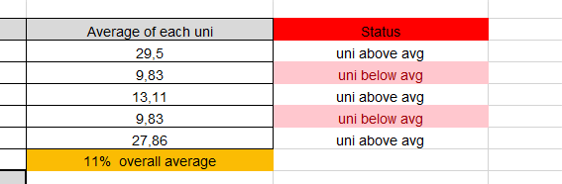
Figure 2 is a Bar Graph with a Line Graph, the above figure gives the reader insight on the numbers of each University that might be considered to have a recycling system implemented by a Waste Reduction Specialist. The Line Graph is a shows the average of each university obtained number against the other universities and against the overall average which is 11%.

Figure 3 : Percentages of the duties of a Waste Reduction Specialist.
Figure 3 is a Pie Chart; this figure gives the reader insight on the percentages of the duties of a Waste Reduction Specialist chosen by the respondents based on their knowledge.

Figure 4 : Do Waste Reduction Specialists implements systems to reduce waste.
Figure 4 is a Vertical Bar Graph, this figure shows the number of the total respondents (65) and as well as the number of the respondents that chose “Yes”/ “No” to the question on the title of the graph being, “Do Waste Reduction Specialists implement systems to reduce waste?”.

Figure 5 : Scale of the level of assistance a Reduction Specialist Requires.
Figure 5 is a Line Graph; this graph gives the readers insight on the numerical values derived from the survey that was issued out. These numbers show the sum of each level chosen by the respondents. The levels being 1 to 5 the level of assistance, starting from “No assistance” to “has huge assistance”.

Figure 6 : Estimation of the annual gross salary of a Waste Reduction Specialist.
Figure 6 is a 3D Bar Graph, this above figure gives the reader insight to the estimations of the annual gross salary of a Waste Reduction Specialist made by the respondents, the lowest (R 28 033,00) and highest (R 446 408,00) estimation is compared to the correct annual base amount (R 334 547,00) earned by a Waste Reduction Specialist.

ACCESS ANAYLSIS AND INTERPRETATION
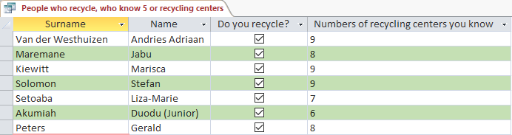
Figure 7 : Query for recycling centres
Figure 7 it is a Query (1) designed to show the respondents who know 5 or more recycling centres.
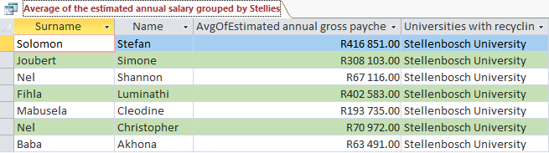Figure 8 : Query for the average estimated annual salary
Figure 8 it is a Query (2) design to show the respondents name and surname with their average estimated annual pay check amount which chose Stellenbosch University as the Institution where you can get a Waste Reduction Specialist degree.
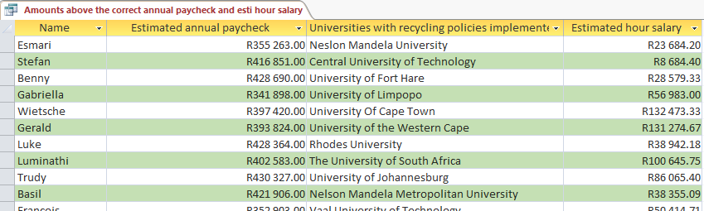
Figure 9 : Query for the amounts above the correct annual pay check and estimated hour salary
Figure 9 it is a Query (3) designed to show the respondents Name, Institution of their choice and as well as the Estimated Annual Gross Pay Check which are below the correct annual gross pay check and as well as the estimated hour salary.
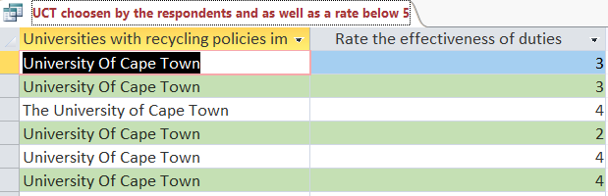
Figure 10 : Query for people who choose UCT with a rate of below 5
Figure 10 it is a Query (4) designed to show the respondents who choose UCT with a rate below 5

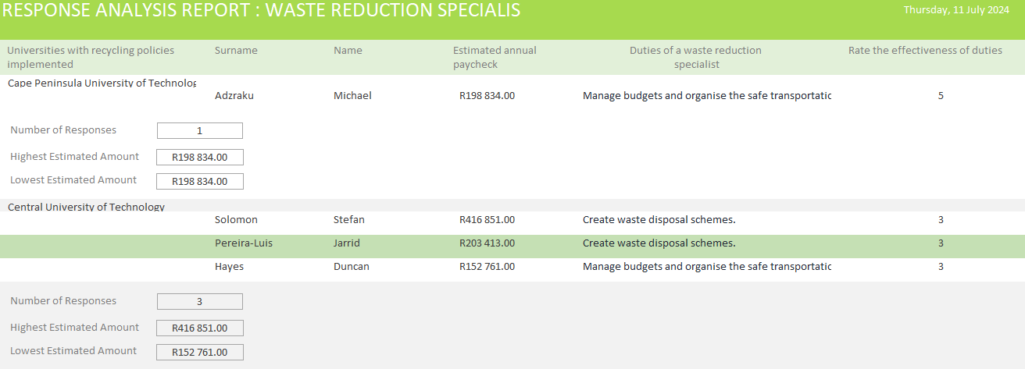
Figure 11 : Report for the analysis of the information derived from the respondents.
Figure 11 it is a Report designed to show all the fields of the Respondents Table grouped by the Institution where you can obtain a Waste Reduction Specialist Degree with calculations in the footer which show the number of respondents that chosen Institution, the highest estimated annual gross pay check and the lowest annual gross pay check.

